News and Information
Rachel Klipa, Office of Public Art
412-391-2060 x237 rklipa@pittsburghartscouncil.org

Bonnie Baxter, DOORS OPEN Pittsburgh
412-583-1424
Bonnie@DoorsOpenPgh.org

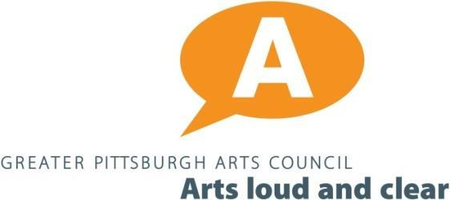
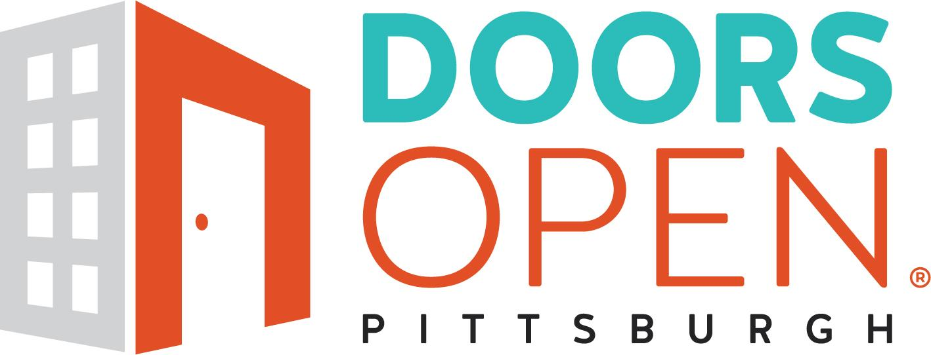

Federal Courthouse and Mural Tour
DOORS OPEN Pittsburgh and the Office of Public Art team up to offer a tour of the Federal Courthouse

Pittsburgh, PA…July 3, 2019…DOORS OPEN Pittsburgh and the Office of Public Art present the Federal Courthouse Tour on July 19 from 2 - 3:30 pm. The tour will feature contemporary artwork and murals from the 1930s, as well as a historical overview of the building and its architectural features.

For its first collaboration, DOORS OPEN Pittsburgh and the Office of Public Art organized a tour of the Federal Courthouse to see artwork located in various courtrooms throughout the building. Historic murals within the courthouse include Stuyvesant van Veen’s Pittsburgh Panorama and Howard Cook’s Steel Industry.

These murals were commissioned by the Treasury Section of Painting and Sculpture, established within the Procurement Division of the Department of the Treasury’s Public Works Branch in October 1934 and was funded by one percent of each construction appropriation, which included public buildings such as post offices and courthouses.

In addition to seeing these works, tour-goers will see contemporary artwork in courtrooms including murals of local landscapes, tapestry, and learn about the courthouse’s art gallery program. Moreover, participants will learn about the history and development of the building,

see historic courtrooms and more contemporary ones, and learn about how courtrooms are designed.

The Federal Courthouse is located 700 Grant Street, Pittsburgh 15219. Participants will meet at the main entrance of the building. Please note, it is mandatory that tour-goers present a state-issued ID before the tour begins. Participants may not bring their cell phone, camera or any other electronic device on the tour; any device brought into the building will be kept in a secure location during the tour.

Photographs during the tour are not permitted. Although the courthouse is open to the public and access to the courthouse is free, this coordinated tour is limited to 25 participants and tickets are $20. To purchase tickets please visit: www.DoorsOpenPgh.org

Please visit ParkPGH to find parking options.

####
About the Office of Public Art
Office of Public Art (OPA) is the leading agent and advocate for public art in Southwestern Pennsylvania. Founded in 2005, OPA is located at the Greater Pittsburgh Arts Council and works with communities and artists throughout the region by providing public art education, commissions, project management, artist selection, and artist residencies in the public realm. OPA collaborates with individuals and organizations in both the public and private sector. For more information, visit: publicartpittsburgh.org.

DOORS OPEN Pittsburgh
DOORS OPEN Pittsburgh, Inc is a 501c3 non-profit organization, created in 2016.
DOORS OPEN Pittsburgh is best known for its annual event in October, that celebrates Pittsburgh’s heritage and architecture by inviting the general public into dozens of building for behind-the-scenes access, or just the opportunity to explore and experience the stories our buildings tell us about our past present and future as a City. In 2019, DOORS OPEN Pittsburgh began presenting a series of Specialty Tours outside of the annual event. For more information: https://doorsopenpgh.org/

